BIGDATA LAB

Reuben.v.Kudnavar
1NT20IS410

Creating database

> use ruben
switched to db ruben
> db
ruben
> db.createCollection("ruben");
{ "ok" : 1 }
> db.roy.drop()
False

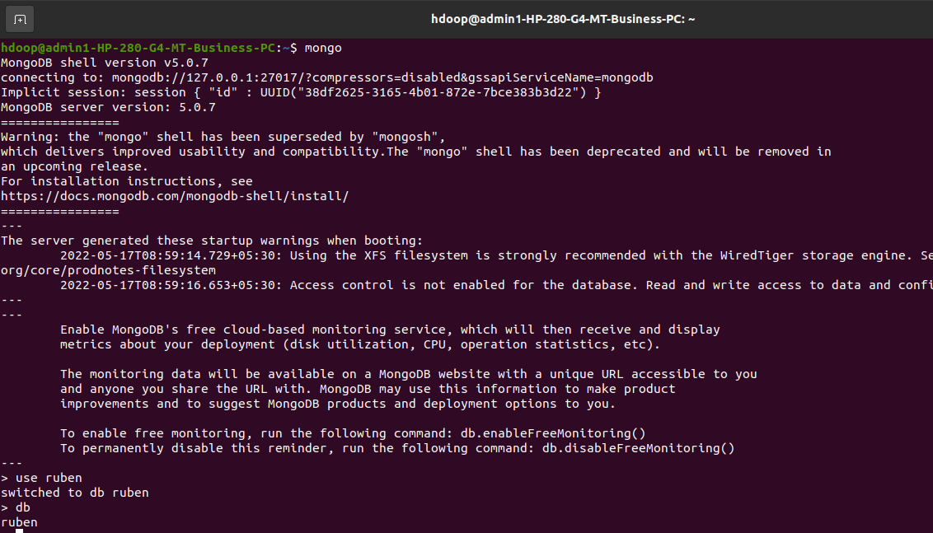

Insert

> db.ruben.insertOne({ "name": "nikhil", "dept": "ISE })
uncaught exception: SyntaxError: "" literal not terminated before end of script :
@(shell):1:54
> db.ruben.insertOne({ "name": "nikhil", "dept": "ISE });
uncaught exception: SyntaxError: "" literal not terminated before end of script :
@(shell):1:55
> db.ruben.insertOne({ "name": "nikhil", "dept": "ISE" })
{
"acknowledged" : true,
"insertedId" : ObjectId("62831e26fc6dbc28eac53297")
}
> db.madhu.count()
0
> db.ruben.count()

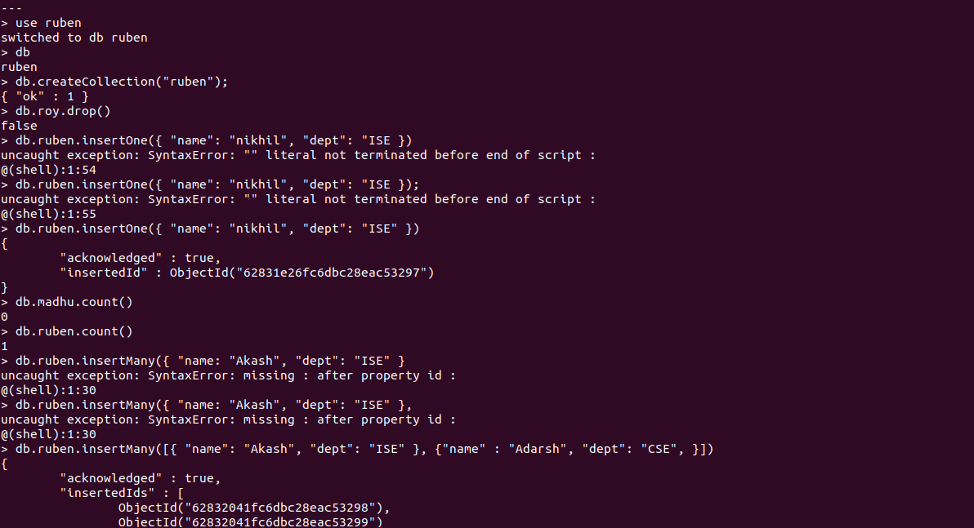

> db.ruben.insertMany({ "name: "Akash", "dept": "ISE" }
uncaught exception: SyntaxError: missing : after property id :
@(shell):1:30
> db.ruben.insertMany({ "name: "Akash", "dept": "ISE" },
uncaught exception: SyntaxError: missing : after property id :
@(shell):1:30
> db.ruben.insertMany([{ "name": "Akash", "dept": "ISE" }, {"name" : "Adarsh", "dept": "CSE", }])
{
"acknowledged" : true,
"insertedIds" : [
ObjectId("62832041fc6dbc28eac53298"),
ObjectId("62832041fc6dbc28eac53299")
]
}
> db.ruben.find()
{ "_id" : ObjectId("62831e26fc6dbc28eac53297"), "name" : "nikhil", "dept" : "ISE" }
{ "_id" : ObjectId("62832041fc6dbc28eac53298"), "name" : "Akash", "dept" : "ISE" }
{ "_id" : ObjectId("62832041fc6dbc28eac53299"), "name" : "Adarsh", "dept" : "CSE" }
> db.ruben.find().pretty()
{
"_id" : ObjectId("62831e26fc6dbc28eac53297"),
"name" : "nikhil",
"dept" : "ISE"
}
{
"_id" : ObjectId("62832041fc6dbc28eac53298"),
"name" : "Akash",
"dept" : "ISE"
}
{
"_id" : ObjectId("62832041fc6dbc28eac53299"),
"name" : "Adarsh",
"dept" : "CSE"
}

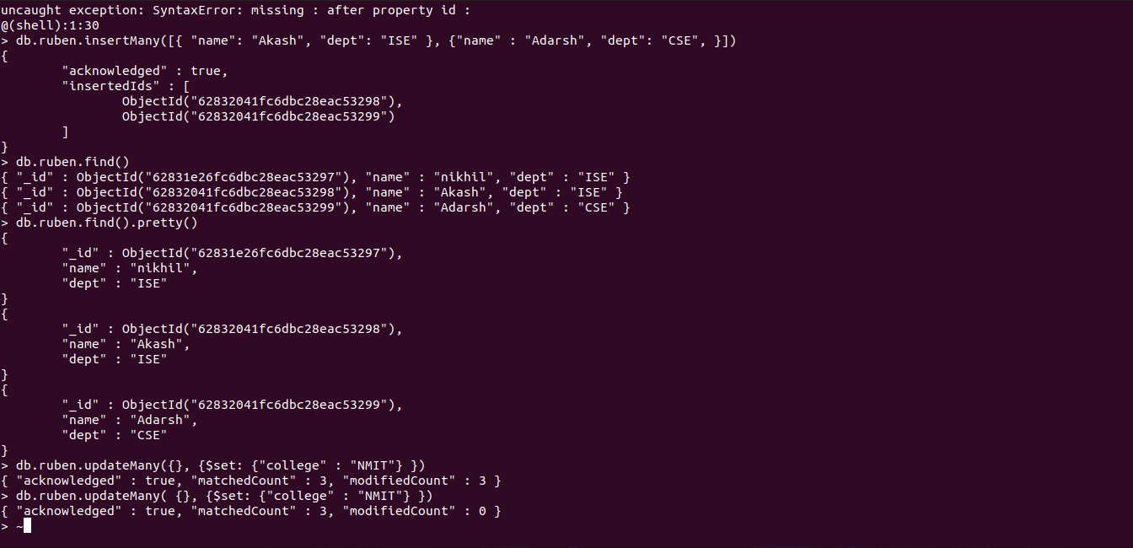

Update

> db.ruben.updateMany({}, {$set: {"college" : "NMIT"} })
{ "acknowledged" : true, "matchedCount" : 3, "modifiedCount" : 3 }
> db.ruben.updateMany( {}, {$set: {"college" : "NMIT"} })
{ "acknowledged" : true, "matchedCount" : 3, "modifiedCount" : 0 }
> ~db.ruben.find().pretty()
-1
> db.ruben.find().pretty()
{
"_id" : ObjectId("62831e26fc6dbc28eac53297"),
"name" : "nikhil",
"dept" : "ISE",
"college" : "NMIT"
}
{
"_id" : ObjectId("62832041fc6dbc28eac53298"),
"name" : "Akash",
"dept" : "ISE",
"college" : "NMIT"
}
{
"_id" : ObjectId("62832041fc6dbc28eac53299"),
"name" : "Adarsh",
"dept" : "CSE",
"college" : "NMIT"
}
> db.ruben.updateOne({ "name" : "Akash"}, {$set : {"dept" : "CSE"} })
{ "acknowledged" : true, "matchedCount" : 1, "modifiedCount" : 1 }
> db.ruben.find().pretty()
{
"_id" : ObjectId("62831e26fc6dbc28eac53297"),
"name" : "nikhil",
"dept" : "ISE",
"college" : "NMIT"
}
{
"_id" : ObjectId("62832041fc6dbc28eac53298"),
"name" : "Akash",
"dept" : "CSE",
"college" : "NMIT"
}
{
"_id" : ObjectId("62832041fc6dbc28eac53299"),
"name" : "Adarsh",
"dept" : "CSE",
"college" : "NMIT"
}

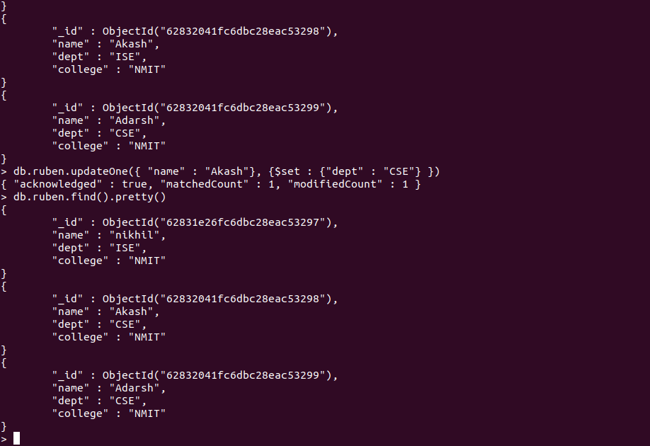

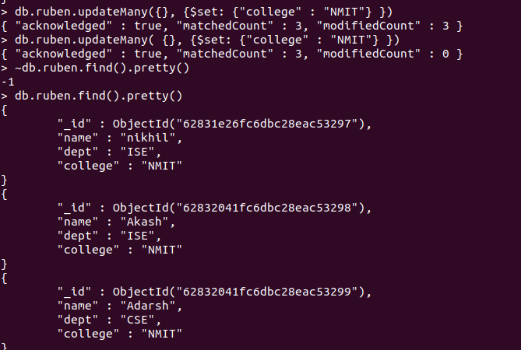

Delete

> db.ruben.deleteOne({ "name" : "Ullal" })
{ "acknowledged" : true, "deletedCount" : 0 }
> db.ruben.find().pretty()
{
"_id" : ObjectId("62831e26fc6dbc28eac53297"),
"name" : "nikhil",
"dept" : "ISE",
"college" : "NMIT"
}
{
"_id" : ObjectId("62832041fc6dbc28eac53298"),
"name" : "Akash",
"dept" : "CSE",
"college" : "NMIT"
}
{
"_id" : ObjectId("62832041fc6dbc28eac53299"),
"name" : "Adarsh",
"dept" : "CSE",
"college" : "NMIT"
}
> db.ruben.deleteOne({ "name" : "nikhil" })
{ "acknowledged" : true, "deletedCount" : 1 }
> db.ruben.find().pretty()
{
"_id" : ObjectId("62832041fc6dbc28eac53298"),
"name" : "Akash",
"dept" : "CSE",
"college" : "NMIT"
}
{
"_id" : ObjectId("62832041fc6dbc28eac53299"),
"name" : "Adarsh",
"dept" : "CSE",
"college" : "NMIT"
}

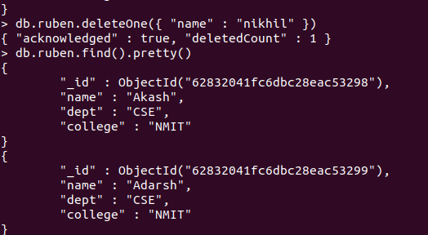

Update using unset

> db.ruben.updateOne( {"name" : "irfan"}, { $unset : { "dept" : "" }})
{ "acknowledged" : true, "matchedCount" : 0, "modifiedCount" : 0 }
> db.ruben.updateOne( {"name" : "Akash"}, { $unset : { "dept" : "" }})
{ "acknowledged" : true, "matchedCount" : 1, "modifiedCount" : 1 }
> db.ruben.find().pretty()
{
"_id" : ObjectId("62832041fc6dbc28eac53298"),
"name" : "Akash",
"college" : "NMIT"
}
{
"_id" : ObjectId("62832041fc6dbc28eac53299"),
"name" : "Adarsh",
"dept" : "CSE",
"college" : "NMIT"
}
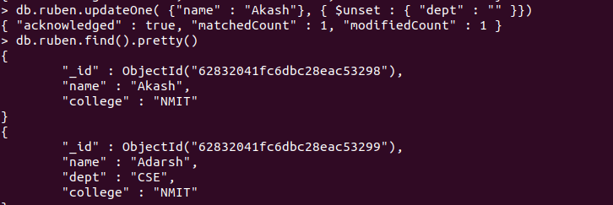

> db.ruben.updateOne( {"name" : "Akash"}, { $set : { "dept" : "ISE" }})
{ "acknowledged" : true, "matchedCount" : 1, "modifiedCount" : 1 }
> db.ruben.find().pretty()
{
"_id" : ObjectId("62832041fc6dbc28eac53298"),
"name" : "Akash",
"college" : "NMIT",
"dept" : "ISE"
}
{
"_id" : ObjectId("62832041fc6dbc28eac53299"),
"name" : "Adarsh",
"dept" : "CSE",
"college" : "NMIT"
}
> db.ruben.replaceOne( {"name" : "Akash"}, {"name" : "Irfan", "dept" : "ISE", "college" : "NMIT" })
{ "acknowledged" : true, "matchedCount" : 1, "modifiedCount" : 1 }
> db.ruben.find().pretty()
{
"_id" : ObjectId("62832041fc6dbc28eac53298"),
"name" : "Irfan",
"dept" : "ISE",
"college" : "NMIT"
}
{
"_id" : ObjectId("62832041fc6dbc28eac53299"),
"name" : "Adarsh",
"dept" : "CSE",
"college" : "NMIT"
}
> db.ruben.updateOne( {"name" : "Akash"}, { $set : { "dept" : "ISE" }})

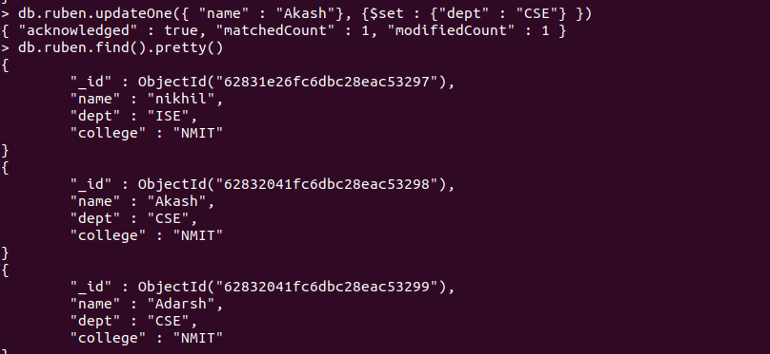

Replace

